**Sync EC2 with S3**

1. Create a IAM role

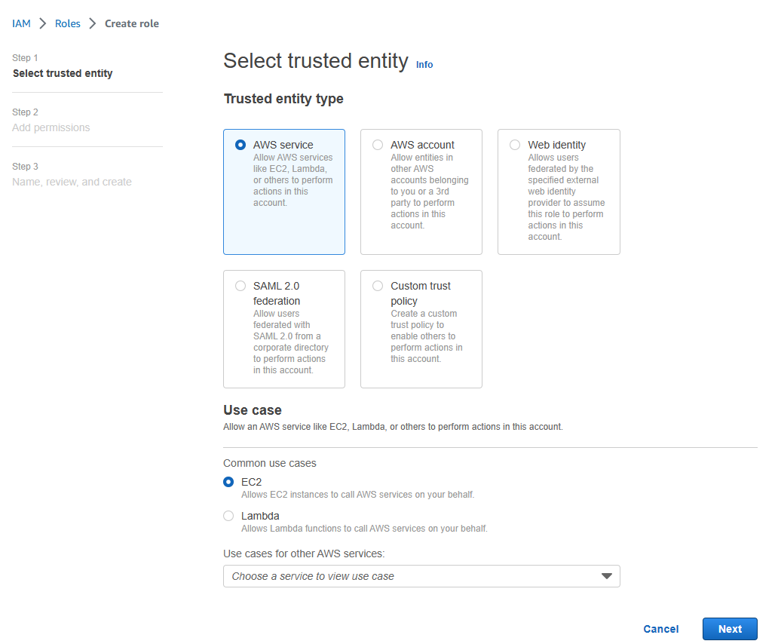

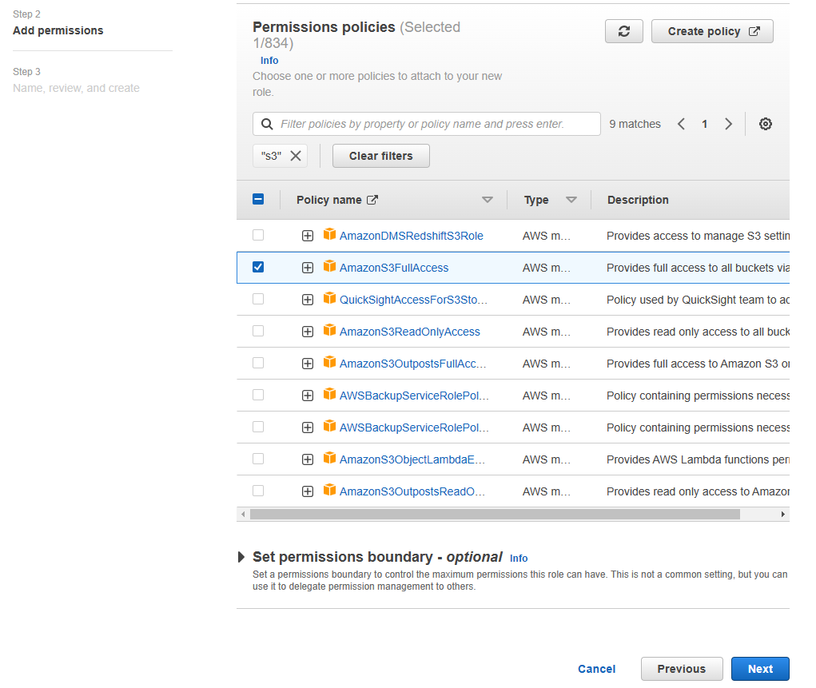

1. Create an instance
   1. Select OS as Ubuntu
   2. Create a key pair with key format ‘.ppk’
   3. Under Advanced details select previously created IAM role as IAM instance profile.

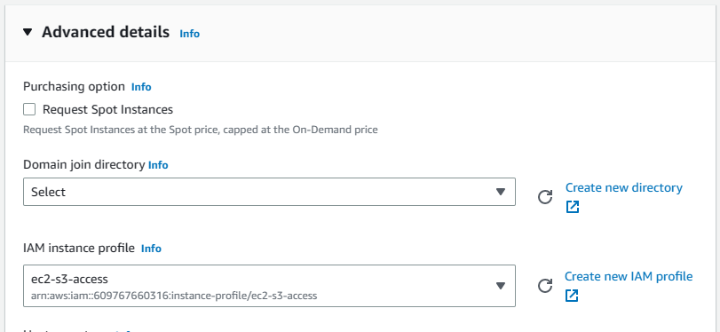

* 1. Launch instance.

1. Create S3 bucket where the EC2 files will sync.
2. Connect EC2 instance from Putty or browser
3. Run those command:
   1. sudo –i // for login as root user
   2. apt install unzip // for install unzip
   3. curl "https://awscli.amazonaws.com/awscli-exe-linux-x86_64.zip" -o "awscliv2.zip" // download aws cli
   4. unzip awscliv2.zip // unzip aws cli
   5. sudo ./aws/install // install aws cli
   6. cd /
   7. crontab –e // create cron file
4. Past ‘* * * * * /usr/local/bin/aws s3 sync /var/syncfolder/[ec2 source folder] s3://aws-chrome-lambda-s/ec2-backup[s3 bucket arn]’ in nano editor.
5. Click Ctrl+x for exit.
6. Save and exit

